RoboCup Junior
Australia
Rescue / Premier Rescue Rules
2012
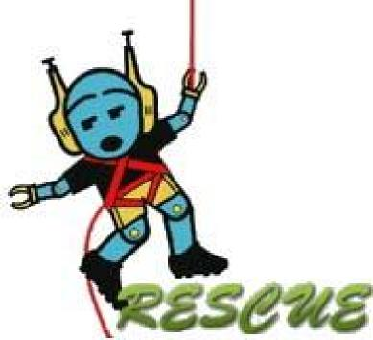

Note: This is part of an attempt to provide some suggestions that could assist the elimination of what appear to be problems within the 2012 Australian RoboCup Junior Rescue regulations, in the hope that discussion will be stimulated, and possibly result in the removal of some contradictions. The suggested changes are mostly shown by a green highlight; more detail of 18 suggestions at: http://www.drgraeme.net/DrGraeme-RoboCup-Australia/RoboCupAusV1/2012RoboCupAus/2012RoboCupJuniorAus.htm
This is NOT an official document from RoboCup Junior Australia. To read the current official Australian RoboCup Junior Rescue regulations, go to http://www.robocupjunior.org.au/rescue .
http://www.robocupjunior.org.au/

Introduction 3
Spirit 3
Sharing 3
Local Variations 3
Age Limit 3
1. The Challenge 3
1.1. The Scenario 3
2. The Field 4
2.1 Tiles 4
2.2. Lighting 7
3. Robots 7
3.1. Size 7
3.2. Control 8
3.3. Construction 8
3.4. Robot Configuration 8
3.5. Inspection 9
3.6. Students 9
3.7. Violations 9
4. The Victims 9
5. Game Play 10
5.1. Pre-game Set-up 10
5.2. Length of a Game 10
5.3. Game Zone 10
5.4. Start of the game 10
5.5. Restarts 10
5.6. Following the Line 11
5.7. Scoring 12
5.8. Preliminary Rounds 13
5.9. Finals series 13
6. Conflict Resolution 14
6.1. Referee 14
6.2. Officials 14
6.3. Special Circumstances 14
7. Documentation 14
7.1. Log Books 14
8. Code of Conduct 14
8.1. Fair Play 14
8.2. Behaviour 15
8.3. Mentors 15
RoboCup Rescue Mounting Blocks 16
RoboCup Rescue Doorways 17
Introduction
Spirit
It is expected that all participants, students and mentors, will respect the aims and ideals of RoboCup Junior as set out in our mission statement. In turn, the volunteers, referees and officials will act within the spirit of the event to ensure the competition is competitive, fair and most importantly fun. “It is not whether you win or lose, but how much you learn that counts.”
Sharing
It is the overall desire of RoboCup Junior competitions, that any technological and curricular developments will be shared with other participants after the competition. Any developments including new technology and software examples may be published on the RoboCup Junior web site after the event, furthering the mission of RoboCup Junior as an educational initiative. Participants are strongly encouraged to ask questions of their fellow competitors to foster a culture of curiosity and exploration in the fields of science and technology.
Local Variations
These rules will be in use for the 2012 Australian National Championships. State and Regional competitions may implement minor variations with respect to age groups, running of the rescue rounds or other rule modifications. These variations will be communicated to the participants through email and/or on their relevant website prior to the state competition.
Age Limit
Students should participate in one of two divisions, Rescue or Premier Rescue.
Rescue: Every team member must have less than two full years’ experience.
Eg. I competed last year in Rescue. I can compete in Rescue this year. I cannot compete in rescue
next year.
Premier Rescue: Open to all students up to those studying at a recognised secondary provider.
1. The Challenge
1.1. The Scenario
1.1.1. A terrible earthquake has hit the city and caused a large chemical storage unit to rupture spilling thousands of litres of toxic chemicals in the centre of the city. There is a person trapped on a sinking water tank in the middle of the chemical spill. Rescue crews are having trouble entering the city with the amount of rubble around and rescue from the air has also been ruled out due to the noxious gases rising around the city.
1.1.2. Rescue: It has been decided that the best form of rescue is the deployment of an autonomous robot that can navigate to the scene and rescue the stranded person on the Water Tank by pushing or dragging the water tank out of the chemical spill.
1.1.3. Premier Rescue: It has been decided that the best form of rescue is the deployment of an autonomous robot that can navigate to the scene and remove the water tank from the chemical spill and place it in its original orientation safely on the evacuation platform for later collection by an aircrew.
2 The Field
2.1 Tiles
2.1.1. The field will consist of 594 mm x 594 mm tiles, with differing patterns. The final selection of tiles and their arrangement will not be revealed until the day of the competition. Competition tiles may be mounted on a hard backing material of any thickness.
2.1.2. There will be a minimum of 4 tiles in a competition field.
2.1.3. There are different tile designs (see examples below). Tile size has been selected so that each tile can be manufactured from an A1 sheet of paper (594 mm x 841 mm)
Note: The official RoboCup Junior Australia Rescue Field used in competitions can be obtained from MTA
2.1.4. The background colour of each tile is white with the line 15 mm in width and black in colour. 2.1.5. All lines meet the edge of the tile halfway along its length.
2.1.6. Intersections markers are green and 40 mm x 40 mm in dimension and indicate the correct path to follow.
2.1.7. The organising committee will make every possible attempt to ensure there are no ‘bumps’ between tiles although there may be slight deviations in height of up to 3 mm. Competitors must be prepared to deal with these slight imperfections in height.
2.1.8. Rescue: The tiles will be selected from Pool A only (see examples below), although competitors can expect tiles to be duplicated and/or omitted.
2.1.9. Premier Rescue: The tiles and obstacles will be selected from both Pool A and Pool B, although competitors can expect tiles to be duplicated and/ or omitted.
Note: For 2012 only, the Gridlock will NOT be part of Pool B.
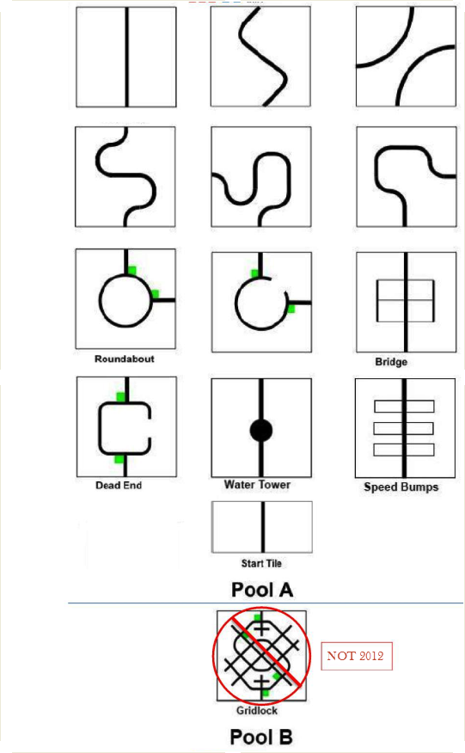
2.1.10. The “Bridge” tile will consist of a white raised section with the following dimensions with a black line across the middle of the bridge;
2.1.11. The “Speed Bumps” will consist of rectangular sections, 200 mm x 30 mm, white in colour,
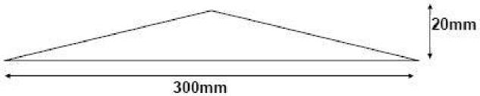
with a height of 5mm. A black line will run across the top surface of the speed bump.
2.1.12. The “Water Tower” will be a clear 1.25L PET soft drink bottle filled with water. The tower is not to be intentionally moved from its location. When navigating the water tower, robots must regain following the line before the robot fully exits the tile. The water tower will be clear with all external labels removed if possible. Should the line not be reacquired within the tile, the robot will have been deemed 'loss of line' and be required to start from the beginning of the course.
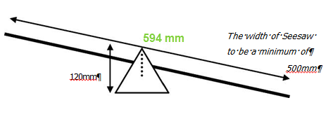
2.1.13. The See Saw may be introduced onto any straight section of the course. Its length will be 594 mm and the central pivot will be from 70 mm. Robots will need to be able to climb and descend both sides while following the line. The “See Saw” will be constructed from 10 mm plywood or similar. The pivot board is 594 mm x 500 mm. The two supports will 120 mm equilateral triangles. A base piece 120 mm x 505 mm will join the two supports together. A 5 mm hole 70 mm from the base of the supports will be the pivot point for the “Sea Saw”.
On the edge of the Pivot board drill a 3 mm hole 295 mm from one end on both sides. This will make the Pivot board heavy on one end so that it always tilts one way. Use a 50 mm screw on each side to join the Pivot board to the Supports.
2.1.14.1 The final tile will be a 594 mm x 594 mm tile, white background with the chemical spill indicated by the green area.
2.1.14.2 At the point where the black line meets the green area, there will be a piece of reflective aluminium foil, 40 mm x 15 mm in dimension.
2.1.15. Premier Rescue: The End Tile will also have the evacuation platform, 70 mm high, 200 mm wide and 70 mm deep located at the rear of the chemical spill. The platform will be painted the same colour as the location rectangle on the finishing tile.
2.1.16. No provision will be made to assist robots that drive off a tile, from getting back on the tile. Competitors need to be aware that in some competitions, tiles may be mounted on thick backing; making it difficult to get back on a tile should the robot come off.
2.1.17. Tiles may be elevated off the floor by 90 mm. Tiles will then be used as ramps to allow the robots to ‘climb’ up to and down from the elevated tile. Elevator blocks are to be made of 70 mm x 70 mm wood painted the same colour as the location rectangle on the finishing tile
2.2. Lighting
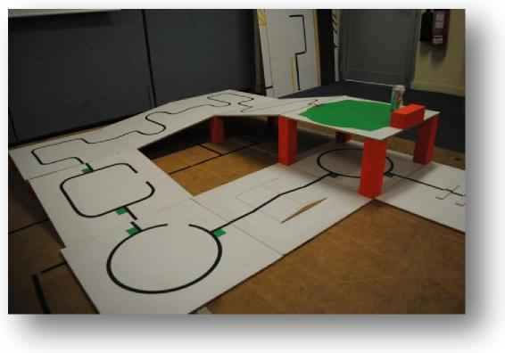 | Note: Elevation blocks for 2012 will be 90 mm blocks only.

2.2.1. Teams must come prepared to calibrate their robots based on the lighting conditions available at the venue.
2.2.2. The organising committee will make a reasonable effort to keep ambient light to a low level with infra-red (IR) sources from incandescent lights and natural lighting minimised.
2.2.3. Teams must also be prepared for other form of light interference from electronic devices and should take steps to protect their robot.
3. Robots
3.1. Size
3.1.1. The robot must be able to pass through a doorway 180 mm wide and 180 mm high for the rescue division. The robot must be able to pass through a doorway 270 mm wide and 270 mm high for the premier rescue division.

3.2. Control
3.2.1. Robots must be controlled autonomously.
3.2.2. Robots must be started manually by humans.
3.2.3. The use of remote control of any kind is forbidden.
3.3. Construction
3.3.1. Any robot kit or building materials may be used, as long as the robot fits the above specifications and as long as the design and construction are primarily and substantially the original work of the student(s) (see section 3.3)
3.3.2. Robots should be well engineered and constructed. The robot should not fall apart during the game.
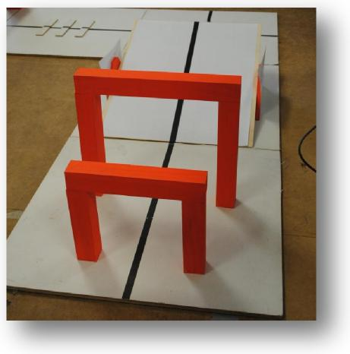
3.4. Robot Configuration
3.4.1. Robots must be able to navigate through a ‘Doorway’ that will be placed anywhere on the field in each round. The doorway will consist of three (3) pieces of solid wood 41 mm x 41 mm. The Doorway pieces will not be fixed together. Robots that knock over the Doorway will need to restart the course.
Rescue: The Doorway opening will be 180 mm wide and 180 mm high, with the inner surface of the two uprights placed 90 mm from the centre of the line.
Premier Rescue: The Doorway opening will be 270 mm wide and 270 mm high, with the inner surface of the two uprights placed 135 mm from the centre of the line.
3.4.2. The doorway will be placed somewhere on the first two (2) tiles.
3.4.3. Rescue: robots must NOT increase in size
3.4.4. A robot entered into the premier rescue division must have a demonstrable mechanism with the potential to rescue the victim as specified in section 1.1.3
3.5. Inspection
3.5.1. The robot will be examined by a panel of referees before/during or after the tournament to ensure that the robot meets the constraints described above.
3.5.2. It is the responsibility of teams to have their robot re-inspected if their robot is modified at any time during the tournament.
3.6. Students
3.6.1. Team member(s) will be interviewed and asked to explain the operation of their robot in order to verify that the construction and the programming of the robot is their own work. Logbooks or design diaries must be provided. (see section 7)
3.6.2. Students may be asked questions about their preparation efforts, and they may be requested to answer surveys and participate in videotaped interviews for research purposes.
3.6.3. Commercial robot kits may be used but must be substantially modified by the students. 3.6.4. It is highly unlikely that a team will be able to legally use a robot identical to another team’s robot from previous years, or use a robot that is identical to another team’s robot.
3.7. Violations
3.7.1. Any violations of the inspection rules will prevent the robot from competing until modifications are effected.
3.7.2. Modifications must be made within the time schedule of the tournament. Game play will not be delayed due to late teams.
3.7.3. If a robot fails to meet all specifications (including modifications) the robot will be disqualified from that game (but not the tournament).
3.7.4. If there is excessive mentor assistance or the work on the robots is not substantially original work of the students, the team will be disqualified from the tournament.
4. Victim
4.1.1 The victim will be represented by either a standard 375 ml aluminium can, standing upright, with no markings OR a standard 375 ml aluminium can wrapped in aluminium foil or aluminium foil tape.
4.1.2. The can will contain material such as rice bringing the weight of the victim to 100 gms. A liquid should not be used to add weight to the can.
5. Game Play
Games will be organised into rounds, then a finals series.
5.1. Pre-game Set-up
5.1.1. Organisers will make a reasonable effort to provide the teams access to the competition area prior to the start of the competition.
5.1.2. Organisers will make a reasonable effort to allow at least 10 minutes of setup time before each game. Participants should be aware, however, that situations may arise where these conditions cannot be met; and so participants should arrive prepared to cope under conditions that are less than ideal.
5.2. Length of a Game
5.2.1. A time limit of 120 seconds will be imposed. Organisers will ensure that the competition maze design will be of adequate length for this time limit.
5.3. Game Zone
5.3.1. An area around the field will be designated as the “game zone”. No one is allowed inside the game zone except for the robot handlers and the referee.
5.4. Start of the game
5.4.1. One team member is elected as the robot handler. Only that team member is permitted to handle the robot during the game. All other team members must remain outside the game zone.
5.4.2. The robot is placed at the starting position, and then checked by the referee.
5.4.3. At the instruction of the referee, the robot’s handler is to start the program on the robot.
5.4.4. A start tile consisting of a lead in black line will be used, although it will not count for any points. Robots are to start behind the join between the start tile and the first course tile.
5.5. Restarts
5.5.1. A robot may re-start the run as the handlers deem necessary within the 120 seconds game time.
5.5.2. The robot must be positioned back at the start and checked by the referee
5.5.3. The game clock will continue to run during all restarts.
5.5.4. There is no limit to the number of restarts within the 120 seconds game.
5.5.5. Points are awarded for each successfully completed tile. Points not gained in one run can be gained in subsequent runs adding to the accumulated points until all tiles have been successfully completed.
5.5.6. A robot must restart if:
- The robot ceases to follow the line,
- The robot is touched by a human,
- The robot moves off the field.

5.5.7 For the National Competition, the restart location will be the start tile of the course. For state and regional competition, organisers "may" implement the Alternative Restart rule. This decision will be announced to competitors well in advance of the competition day.
Alternative Restart rule. Restarts, when required, are placed at the beginning of the maze for the first 60 seconds of a round. During the 2nd 60 seconds, should a robot fail a tile twice, it can skip that tile and all preceding tiles.
eg. A robot begins course and reaches the third tile, an intersection tile, and cannot navigate through the tile. The robot must be restarted as many times as it fails for the first 60 seconds. If the robot has failed at least twice, the moment the stop watch reaches 60 seconds the robot can skip to the next tile. Further along the course the robot cannot navigate through tile 6. The robot can be taken back to the start of tile 4, the last starting point, and have a 2nd attempt. If the robot fails again, the robot can skip the 6th tile and the start of the 7th tile becomes the new re-start point, and so on. A robot that fails to complete a rescue can restart at the beginning of the Rescue Tile.
Note: Points will not be awarded for the tile(s) that have been missed.
5.6. Following the Line
5.6.1. The robot must follow the line completely to enter the chemical spill.
5.6.2. Where there are multiple paths, the robot may take any path.
5.6.3. Where the line is discontinuous, and there is no continuous path through the tile, the robot may search for the recommencement of the line, but must not completely leave the tile before re-finding the line.
5.6.4. For the purposes of determining if a robot has left the line or left the tile, the referee will use the “convex hull” of the robot. This measure is done by stretching an imaginary rubber band around the extremities of the robot, and using the enclosed space as a silhouette.
5.6.5. Some portion of the continuous line segment must be under the robots convex hull. Or, in the case of a discontinuous line, some part of the tile must be under the robot silhouette.
5.6.6. Once the robot has entered the chemical spill tile it is no longer required to “follow the line”. It may enter the chemical spill in any direction in its efforts to rescue the victim. However, if the robot leaves the final tile, it will have to restart.
5.7. Scoring
5.7.1. Teams will be awarded 10 points for each tile that their robot successfully negotiate. Eg, robots reaching the 4th tile would have successfully negotiated 3 tiles and be awarded 30 points. 5.7.2. Teams will gain an extra 2 points for each intersection marker they correctly follow. Eg, if a robot correctly follows both shortcut markers on the roundabout, it will be awarded 14 points, 10 points for completing the tile and 4 points for correctly following the shortcut markers.
5.7.3. A timed, eg less than 120 seconds, round is only awarded after maximum points for that round have been gained. Robots that have completed a Rescue but have not gained a full score have the option to begin the course again to obtain any uncollected points.
5.7.4. For Rescue, teams will be awarded an additional 50 points for successfully rescuing the victim. The victim is considered rescued when it is completely outside the chemical spill.
5.7.5. For Premier Rescue, teams will be awarded an additional 50 points for successfully gaining control of the victim eg: grasping and lifting the victim to a height that may allow the victim to be placed on the platform and then begin to move showing full control of the victim. Another 50 points will be awarded for successfully placing and releasing the victim on the evacuation platform, maintaining the victim’s original upright orientation.
5.7.6. If the robot fails to rescue the victim in the allocated time, it will be given a time score of 120 seconds.
5.7.7. A robot must have a full score on a field before a time of less than 120 seconds is given, ie the clock stopped. eg. If a robot completes a rescue but does not have a full score they may restart and attempt to complete the missing section/s. Only when the maximum possible points for the round is achieved will the clock be stopped.
5.7.8 After the preliminary rounds have been run, teams will be ranked according to their Overall Raw Score for their best four rounds.
5.7.9. Should two or more teams have the same Overall Raw Score, further ranking will be performed by finding the sum of the time taken to rescue the victim in the scoring rounds. The team with the lowest time will be ranked higher.
5.8. Preliminary Rounds
5.8.1. There may be multiple preliminary rounds, depending on the time constraints of the tournament.
5.8.2. Each team will play one game per round.
5.8.3. Officials at the competition will determine the order and nature of how each round will be conducted. All teams must consult with the officials at the start of the competition to be informed on how the preliminary rounds will be run.
5.8.6. The victim will be located in a new position in the chemical spill for each round. It will be in the same position for every game in that round.
5.9. Finals series
5.9.1. The top eight ranked teams will be in the quarter-finals.
- 1st ranked team vs 8th ranked team
- 2nd ranked team vs 7th ranked team
- 3rd ranked team vs 6th ranked team
- 4th ranked team vs 5th ranked team

5.9.2. Quarter-finals shall be a head-to-head competition on two separate fields with the victim in the same position on both fields.
5.9.3. Teams in the quarter-finals shall contest 2 games.
5.9.4. Teams will swap fields between games.
5.9.5. The victim will be in the same position for all games. This position will be different to those in the preliminary rounds.
5.9.6. The winners of the quarter-finals will move to the semi-finals, with ranking determined by the scores from the scoring preliminary rounds.
5.9.7. The winner of the 1st/4th and 2nd/3rd match will play off in the Grand final
5.9.8. The losers of the 1st/4th and 2nd/3rd match will play off for 3rd place.
5.9.9. The Grand Final will consist of 2 games, with the team with the highest cumulative score judged the winner. If scores are tied then the lower cumulative time will determine the winner.

6. Conflict Resolution
6.1. Referee
6.1.1. During game play, the referee’s decisions are final.
6.2. Officials
6.2.1. Rule clarification, but no handling of protests, may be made by a committee of three officials. 6.2.2. The three officials will be designated prior to the tournament.
6.2.3. An official must declare any relationship with any of the teams entered in the tournament and shall not referee any team they have a relationship with.
6.3. Special Circumstances
6.3.1. Specific modifications to the rules to allow for special circumstances, such as unforeseen problems and / or capabilities of a team’s robots, may be agreed to at the time of the tournament, provided a majority of the contestants agree.
7. Documentation
7.1. Log Books
7.1.1. Any team that has original (custom) construction of robots or sensors (not freely or commercially available to all competitors) must supply full documentary proof that the developments were wholly the work of the students. This should be in the form of a logbook showing all stages of design, development, testing and construction.
7.1.2. All teams must maintain logbooks detailing the design, development and construction of the robot and its programs.
7.1.3. Failure to produce documentary proof may result in the robot or sensor not being allowed to be used in the tournament.
8. Code of Conduct
8.1. Fair Play
8.1.1. Robots that cause interference with other robots or damage to the field or the victim will be disqualified.
8.1.2. Humans that cause deliberate interference with robots or damage to the field or the victim will be disqualified.
8.1.3. It is expected that the aim of all teams is to play a fair and clean game of robot rescue.
8.2. Behaviour
8.2.1. All movement and behaviour is to be of a subdued nature within the tournament venue. 8.2.2. Participants who misbehave may be asked to leave the building and risk being disqualified from the tournament.
8.2.3. These rules will be enforced at the discretion of the referees, officials, conference organizers and local law enforcement authorities.
8.3. Mentors
8.3.1. Mentors, Teachers and adults are not allowed in the student work area.
8.3.2. Sufficient seating will be supplied for mentors to remain in a supervisory capacity around the student work area.
8.3.3. Mentors are not to repair robots or be involved in programming of student’s robots.
8.3.4. Mentor interference with robots or referee decisions will result in a warning in the first instance. If this reoccurs, the team will risk being disqualified.

RoboCup Rescue Mounting Blocks
In 2012, Rescue and Premier Rescue tiles may be lifted off the floor a total of 90 mm. Tiles will be used as ramps so that robots can climb from one level to the next.
Note: More than one set of blocks can be used in a round. However, blocks cannot be used on top of one another.
Materials: 4 pieces of 70 mm x 70 mm x 90 mm pine
Note: Tiles are simply offset 5 mm to 10 mm to allow the ramp tile to rest on the block. Use white Gaffer Tape to secure in place
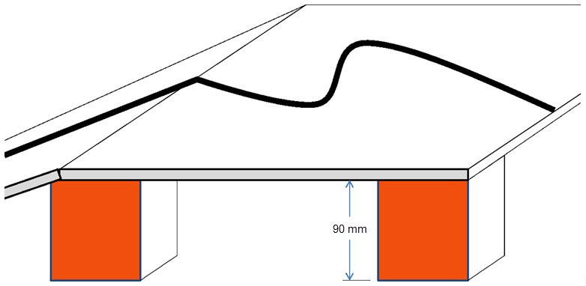
Note: From 2013, there will be three block heights.
Rescue:- 90 mm & 180 mm
Premier Rescue:- 90 mm, 180 mm & 270 mm

RoboCup Rescue Doorways
RoboCup Junior Rescue requires robots to pass through a doorway without knocking it over. There are two different sizes, one for Rescue and one for Premier Rescue
Rescue Materials
1 piece of 41 mm x 41 mm x 262 mm pine (or equivalent)
2 pieces of 41 mm x 41 mm x 180 mm pine (or equivalent)
Premier Rescue Materials
1 piece of 41 mm x 41 mm x 352 mm pine (or equivalent)
2 pieces of 41 mm x 41 mm x 270 mm pine (or equivalent)
